

**Ain Shams University**

**Faculty of Engineering**

**Computer and Systems Department**

**Operating Systems**

***Memory Allocation  
Manual***

|  |  |  |
| --- | --- | --- |
| **مؤمن أحمد مصطفي علي** | **جاسر سامى عبد الهادى** | **الاسم** |
| **2** | **1** | **الفصل** |

**Memory Allocation**

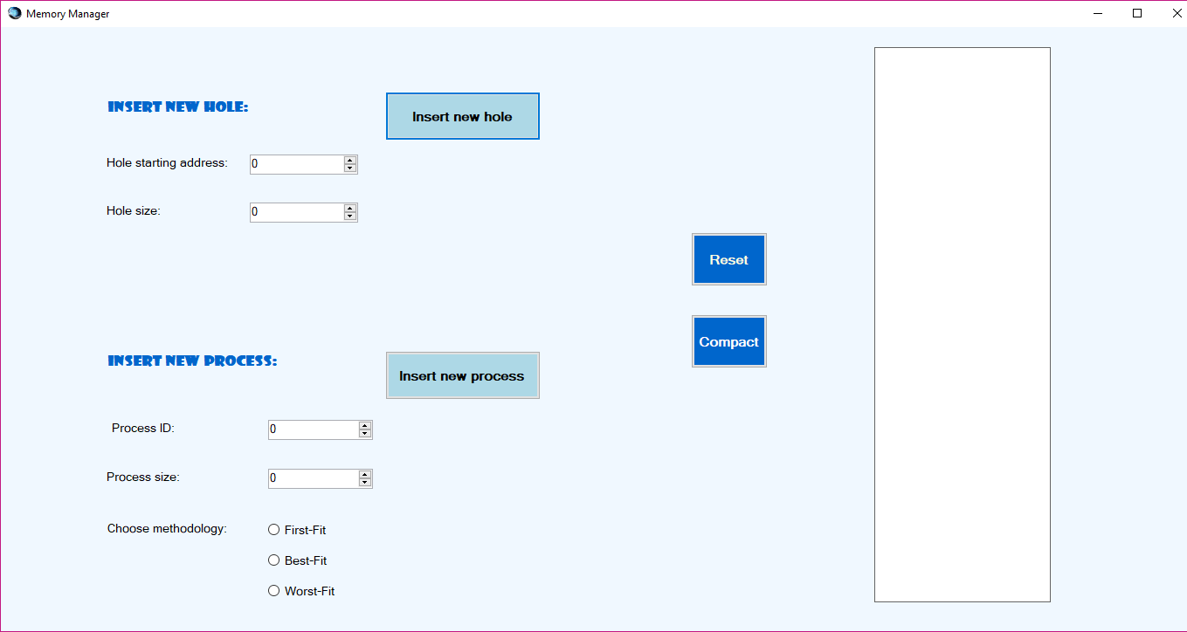

**Steps to use**

* Enter Holes (size and starting address) then click Insert new hole.
* Enter Processes (ID and size) then choose the method of allocation then click Insert new process.

**Processes and holes will be drawn each after insertion in the white rectangle on the right.**

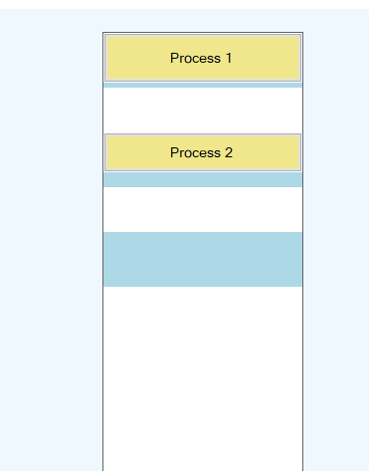

**If there’s no space for a process, then a message will pop expressing that the process will wait.**

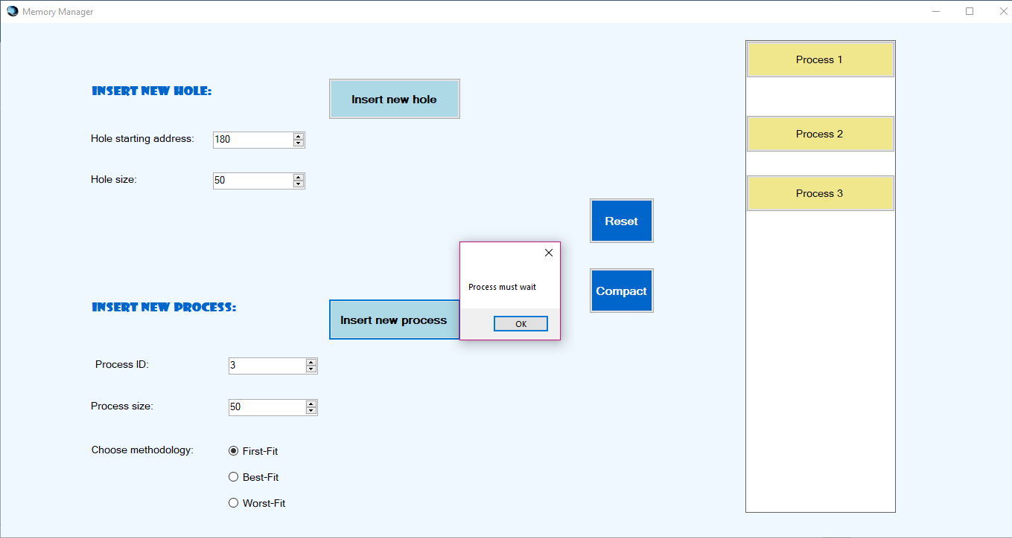

**There are three modes of allocation**

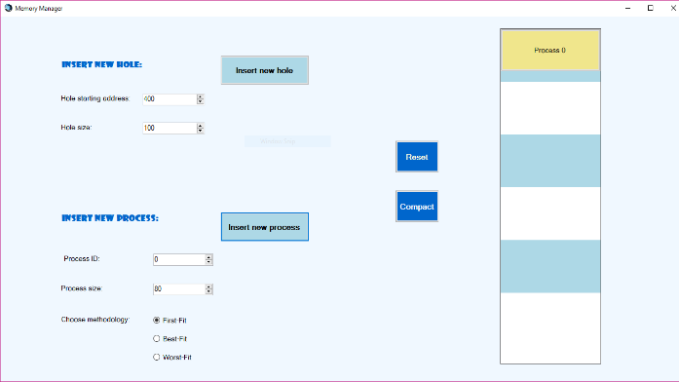**First-Fit Best-Fit**

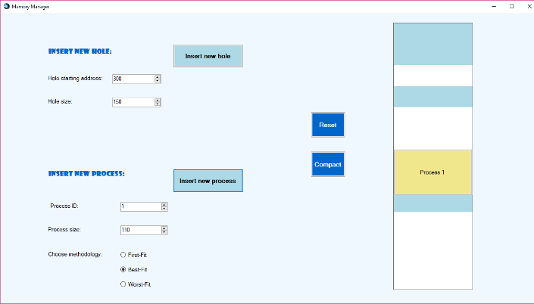

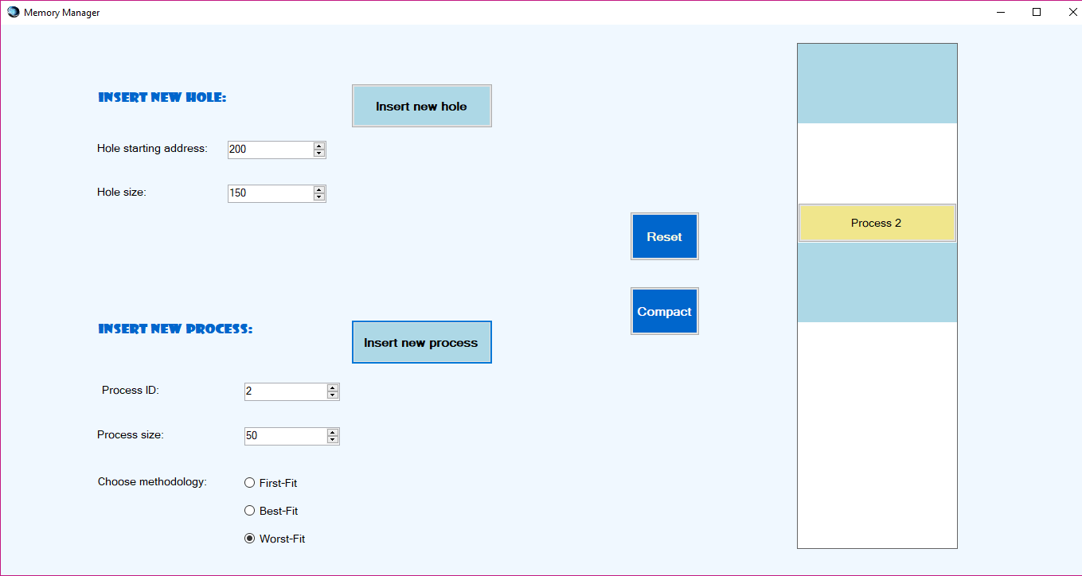**Worst-Fit**

**If you hover over a hole or a process, you will see their info and if you clicked on a process**

**you will deallocate it.**

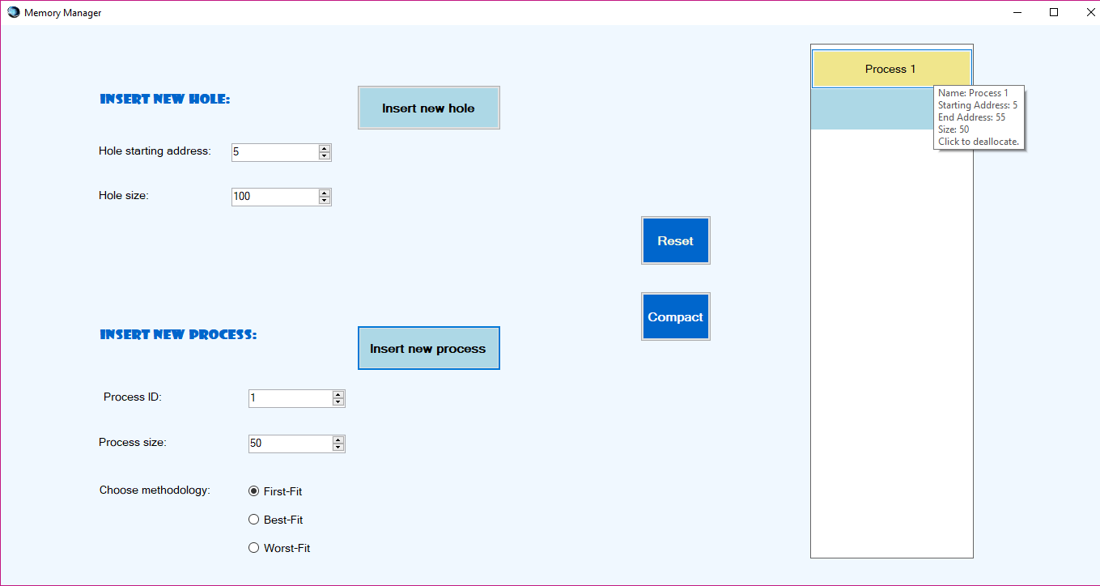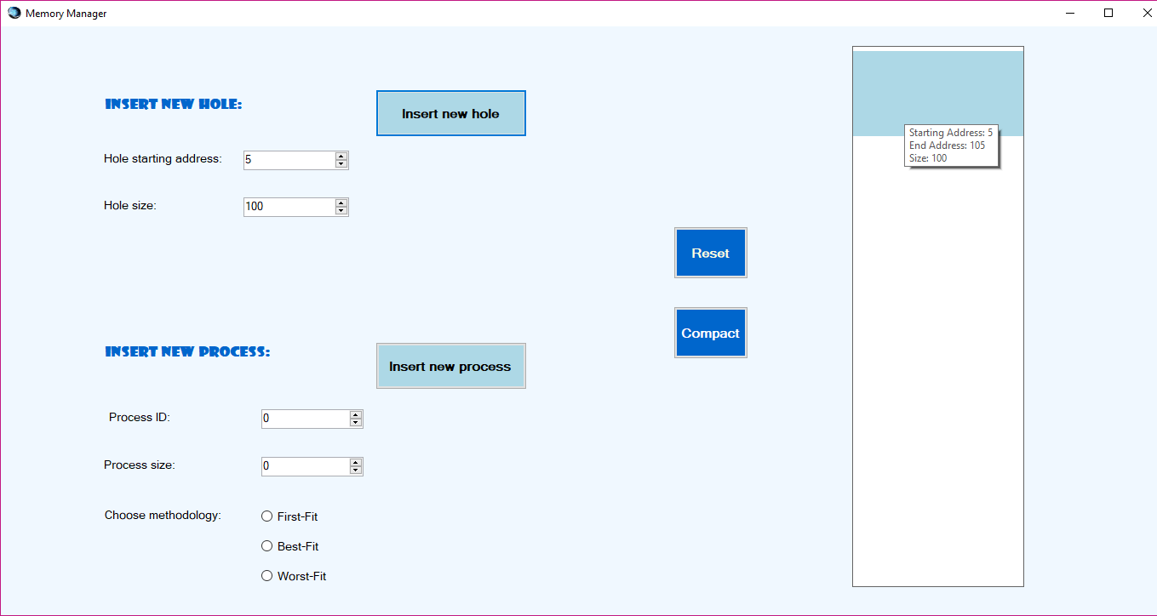

**If you didn’t insert a process or a hole size a message will pop informing you to enter a size.**

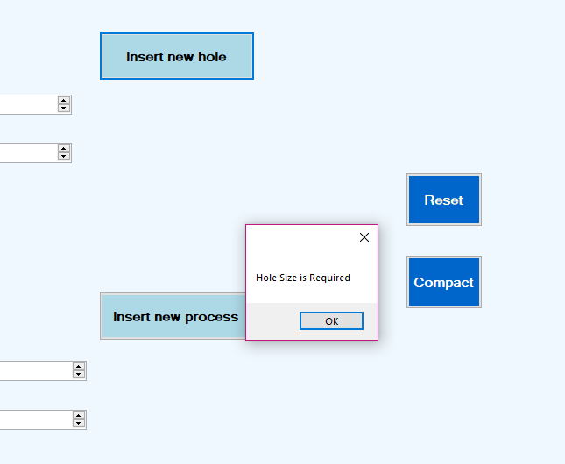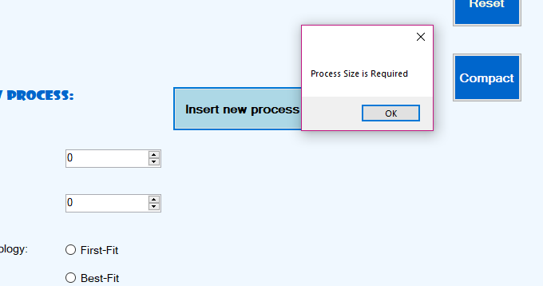

**If you didn’t choose a method of allocation a message will pop informing you to choose one.**

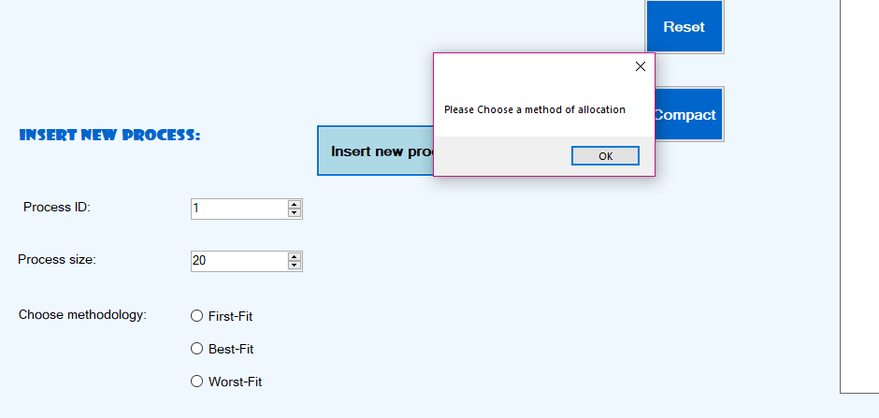

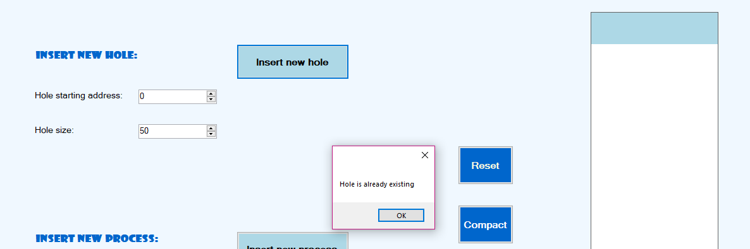**If you insert a hole that is already inserted a message will pop informing you that the hole is already existing.**

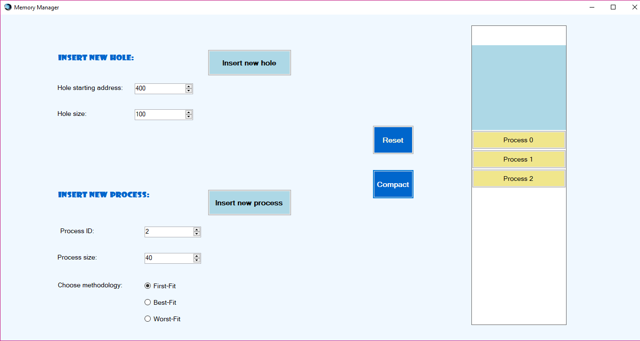**There are two buttons we added Compact button that units all existing holes into one starting from the smallest starting address and shift the existing processes so they start after that hole.**

**Also you can press Rest to delete all processes and holes.**

